Downham West Parish Council

Chairman, Mr Robin Pegg
Willowbrook Cottage, Watermans Way
Salters Lode, Downham Market, Norfolk, PE38 0BD
01366 385815
robin.pegg@openworld .com
Parish Clerk, Mrs Sara Porter
The Old School House, High Street
Stoke Ferry, King’s Lynn, Norfolk, PE33 9SF
01366 502165
dwpc01 @gmail.com

downhamwestparishcouncil.norfolkparishes.gov.uk/ (under construction)

You are hereby summoned to attend the Full Council meeting of Downham West Parish Council on Monday, 12th March 2018 at 7.00pm in the Town Council Offices, Paradise Road, Downham Market, PE38 9HS for the purpose of transacting the business on the agenda below.
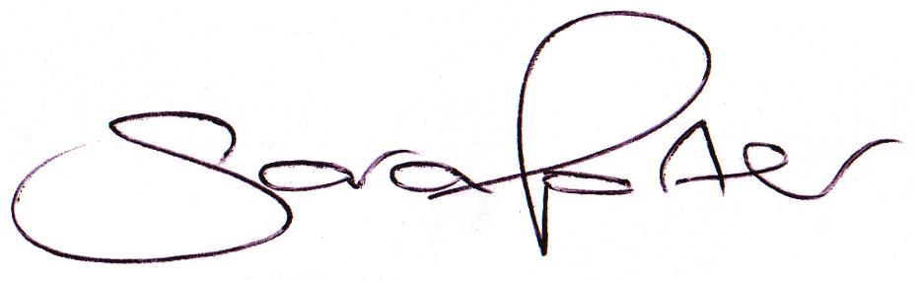

Sara Porter (Mrs)
Parish Clerk
7th March 2018

The meeting is open to the press and public. Any parishioner wishing to raise a matter on the agenda should speak when invited by the Chairman during the ‘Public Open Forum’.

AGENDA
- To receive and accept apologies and reasons for absence
- To receive declarations of interest for items on the agenda and any requests for dispensation
- To agree the minutes of the Council meeting held on Monday, 29th January 2018 (Items 956-968)
- To formally appoint the new Clerk/RFO and approve the Clerk’s salary and expenses
- Update on previous minutes (not listed elsewhere on the agenda and for information only)
To adjourn the meeting in order to allow reports and the press and/or members of the public to address the Council in a PUBLIC OPEN FORUM
Reports
County Councillor
Borough Councillors
Public Participation (maximum 15 minutes – 3 minutes per speaker)
- To discuss Finance
  - To receive and agree the finances since the last meeting and approve payments and pending disbursements to be made:
Date | Payee | Description | Transaction | Net £ | VAT £ | Gross £ | Receipt £
11.02.2018 | E-On | Street Lighting Supply January 2018 | DD | 26.47 | 1.32 | 27.79 | 0.00
19.02.2018 | Former Clerk | Salary (to be reclaimed) | SO | 141.56 | 0.00 | 141.56 | 0.00
11.03.2018 | E-On | Street Lighting Supply February 2018 | DD | 23.90 | 1.20 | 25.10 | 0.00
12.03.2018 | Clerk | Salary February 2018 | 100528 | 168.87 | 0.00 | 168.87 | 0.00
12.03.2018 | Westotec | Street Lighting Jun/Jul/Aug & Feb/Mar | 100529 | 52.75 | 10.55 | 63.30 | 0.00
12.03.2018 | Norfolk ALC | Website domain | 100530 | 30.00 | 6.00 | 36.00 | 0.00
Totals this month |  |  |  | 444.40 | 19.11 | 463.51 | 0.00

  - To approve the travel disbursement for Cllr Swaine attending a BCKL&WN Parish Planning Update session in King’s Lynn on Monday, 5th March 2018
  - To discuss and agree general and specific earmarked reserves
  - To approve the appointment of an Internal Auditor at a cost of £25.00 to carry out services for the 2017/2018 accounts prior to submission to the External Auditor, PKF Littlejohn
- To receive and consider the Council meeting dates for 2018 (draft dates circulated with agenda)
- To receive and discuss the Standing Orders and Financial Regulations and consider the introduction and adoption of other Council related policies
- To consider planning applications, planning decisions and other planning notifications from the BCKL&WN
  - Planning applications:
    - 18/00299/F – Meadow Croft, Lady Drove, Barroway Drove – Demolition of existing flat roof single garage and proposed development of double garage, loft conversion, demolition of existing flat roof utility room and proposed development of a pitched roof utility, re-skin brick walls with replacement bricks and replace existing roof tiles – comments by 15th March 2018
    - 18/00323/F – 10 Farthing Road – Proposed 2 storey side extension, single storey rear extension and single storey replacement outbuilding to form new office/studio – comments by 22nd March 2018

  - Planning decisions:
    - 17/01819/O – Land South of Shining Tree H L C, Downham Road, Salters Lode – Outline Application: Erection of two houses, garages and modified access – Application permitted (Delegated decision)
  - Planning enforcements / appeals and other notifications:
    - Notification of a New Property Address: Orchard Farm House, Ladys Drove, Barroway Drove
  - To receive and consider Late Planning applications
- To receive and discuss general correspondence
  - For action/information
  - Late correspondence
- To receive and discuss correspondence received from the BCKLWN and Norfolk County Council
  - For action/information
  - Late correspondence
- To receive updates and agree action on improvements to the village
  - Speed signs
  - Bus stop
  - Gates
  - Village Tidy Up
- Matters to report to the Clerk
- To receive items for the next Agenda
- To record the date of the next Full Council meeting:
Monday, 23rd April 2018 (including Annual Parish Meeting) at 7.00pm in the Downham Market Town Council Offices, Paradise Road

