Downham West Parish Council

Chairman, Mr Robin Pegg
Willowbrook Cottage, Watermans Way
Salters Lode, Downham Market, Norfolk, PE38 0BD
01366 385815
robin.pegg@openworld .com
Parish Clerk, Mrs Sara Porter
The Old School House, High Street
Stoke Ferry, King’s Lynn, Norfolk, PE33 9SF
01366 502165
dwpc01 @gmail.com

downhamwestparishcouncil.norfolkparishes.gov.uk/ (under construction)

You are hereby summoned to attend the Full Council meeting of Downham West Parish Council on Monday, 23rd April 2018 following the Annual Parish Meeting at 7.00pm in the Town Council Offices, Paradise Road, Downham Market, PE38 9HS for the purpose of transacting the business on the agenda below.
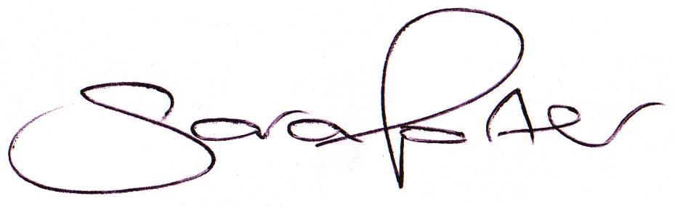

Sara Porter (Mrs)
Parish Clerk
18th April 2018

The meeting is open to the press and public. Any parishioner wishing to raise a matter on the agenda should speak when invited by the Chairman during the ‘Public Open Forum’.

AGENDA
- To receive and accept apologies and reasons for absence
- To receive declarations of interest for items on the agenda and any requests for dispensation
- To agree the minutes of the Council meeting held on Monday, 12th March 2018 (Items 969-983)
- Update on previous minutes (not listed elsewhere on the agenda and for information only)
To adjourn the meeting in order to allow reports and the press and/or members of the public to address the Council in a PUBLIC OPEN FORUM
Reports
County Councillor
Borough Councillors
Public Participation (maximum 15 minutes – 3 minutes per speaker)
- To discuss Finance
  - To receive and agree the finances since the last meeting and approve payments and pending disbursements to be made:
Date | Payee | Description | Transaction | Net £ | VAT £ | Gross £ | Receipt £
05.03.2018 | Barclays Bank Plc | Bank Interest | BACS | 0.00 | 0.00 | 0.00 | 3.20
19.03.2018 | Former Clerk | March salary repaid | BACS | 0.00 | 0.00 | 0.00 | 141.56
12.04.2018 | BCKL&WN | Precept & Council Support Grant | BACS | 0.00 | 0.00 | 0.00 | 5,540.00
12.04.2018 | E-On | Street Lighting Supply March 2018 | DD | 26.47 | 1.32 | 27.79 | 0.00
19.04.2018 | Former Clerk | Salary April (to be reclaimed) | SO | 141.56 | 0.00 | 141.56 | 0.00
23.04.2018 | Clerk | Salary March 2018 | 100533 | 168.87 | 0.00 | 168.87 | 0.00
23.04.2018 | HMRC | PAYE / NI Contributions Jan-Mar 2018 | 100534 | 119.40 | 0.00 | 119.40 | 0.00
23.04.2018 | Norfolk ALC | Annual Membership 2018 2019 | 100535 | 103.58 | 0.00 | 103.58 | 0.00
23.04.2018 | Mr P Akers | Bus Shelter x 6 cleaning | 100536 | 30.00 | 0.00 | 30.00 | 0.00
Totals this month |  |  |  | 589.88 | 1.32 | 591.20 | 5,684.76

  - To receive the Clerk’s financial report and bank reconciliation (circulated with agenda)
  - To receive and consider quotations for a new laptop, MS Office, Antivirus and laptop bag and approve the disbursement (circulated with agenda)
- To confirm the Annual Meeting date in May 2018 and the Ordinary Council meeting date for August 2018
- To receive the updated Standing Orders and Financial Regulations
- To consider planning applications, planning decisions and other planning notifications from the BCKL&WN
  - Planning applications
    - 18/00675/F – Riverbank, Bridge Road – Variation of condition 2 of planning permission 17/00739/F: To amend previously approved drawings – comments by 10th May 2018

  - Planning decisions:
    - 18/00323/F – 10 Farthing Road – Proposed 2 storey side extension, single storey rear extension and single storey replacement outbuilding to form new office/studio – Application permitted (delegated decision)
  - Planning enforcements / appeals and other notifications
  - To receive and consider Late Planning applications
- To receive and discuss general correspondence
  - For action/information
  - Late correspondence
- To receive and discuss correspondence received from the BCKLWN and Norfolk County Council
  - For action/information
  - Late correspondence
- To receive updates and agree action on improvements to the village
  - Speed signs
  - Bus stop
  - Gates
  - Village Tidy Up
    - Salters Lode Lock Dredging – Clerk to report in the absence of Cllr Swain
- Matters to report to the Clerk
- To receive items for the next Agenda
- To record the date of the next Full Council meeting:
Monday, TBA May 2018 (Annual Meeting) at 7.00pm in the Downham Market Town Council Offices, Paradise Road

