Downham West Parish Council

Chairman, Mr Robin Pegg
Willowbrook Cottage, Watermans Way
Salters Lode, Downham Market, Norfolk, PE38 0BD
01366 385815
robin.pegg@openworld .com
Parish Clerk, Mrs Sara Porter
The Old School House, High Street
Stoke Ferry, King’s Lynn, Norfolk, PE33 9SF
01366 502165
dwpc01 @gmail.com

downhamwestparishcouncil.norfolkparishes.gov.uk

You are hereby summoned to attend the Annual Meeting of Downham West Parish Council on Monday, 21st May 2018 at 7.00pm in the Town Council Offices, Paradise Road, Downham Market, PE38 9HS for the purpose of transacting the business on the agenda below.
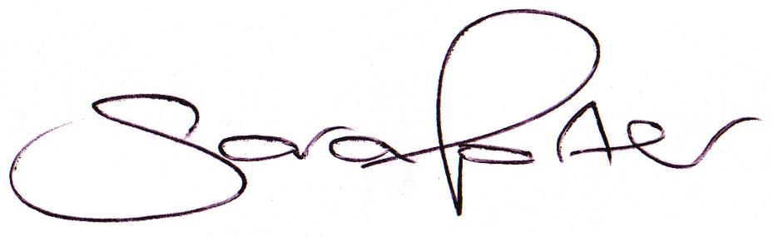

Sara Porter (Mrs)
Parish Clerk
16th May 2018

The meeting is open to the press and public. Any parishioner wishing to raise a matter on the agenda should speak when invited by the Chairman during the ‘Public Open Forum’.
AGENDA
- Election of Chairman of the Council and Declaration of Acceptance of Office
- Election of Vice Chairman of the Council and Declaration of Acceptance of Office
- To receive and accept apologies and reasons for absence
- To receive declarations of interest for items on the agenda and any requests for dispensation
- To agree the minutes of the Parish Council meeting held on Monday, 23rd April 2018 (Items 984-997)
- To review Councillors’ areas of responsibilities, outside body representation and working parties
- To review the Council policies and procedures (available to view on the website unless otherwise stated)
  - Standing Orders
  - Financial Regulations
  - Code of Conduct
  - Powers & Duties
  - Asset Register
  - Parish Council Risk Assessment (for approval)
  - Complaints Procedure – to be written
  - Unreasonably Persistent And/Or Vexatious Complainants – to be written
  - Child Protection – to be written
  - Vulnerable Persons – to be written
  - Grant Aid Policy – to be written
  - Freedom of Information Model Publication Scheme – to be written
  - Equal Opportunities – to be written
  - Press/Media – to be written
  - Councillors’ Registered Declarations of Interests – to be updated if necessary
- Update on previous minutes (not listed elsewhere on the agenda and for information only)
To adjourn the meeting in order to allow reports and the press and/or members of the public to address the Council in a PUBLIC OPEN FORUM
Reports
County Councillor
Borough Councillors
Public Participation (maximum 15 minutes – 3 minutes per speaker)

- To discuss Finance
  - To receive the bank reconciliation (circulated with agenda)
  - To consider paying Mr Paul Akers £100.00 per annum for the continual upkeep of the War Memorial
  - To receive and consider quotations for a new laptop, MS Office, Antivirus, laptop bag and printer and approve the disbursement (circulated with agenda)
  - To receive and agree the finances since the last meeting and approve payments and pending disbursements to be made:
Date | Payee | Description | Transaction | Net £ | VAT £ | Gross £ | Receipt £
12.05.2018 | E-On | Street Lighting Supply April 2018 | DD | 28.18 | 1.41 | 29.59 | 0.00
19.05.2018 | Former Clerk | Salary May 2018 (to be reclaimed) | SO | 141.56 | 0.00 | 141.56 | 0.00
19.05.2018 | Former Clerk | Salary May 2018 (reclaimed) | SO | 0.00 | 0.00 | 0.00 | 141.56
21.05.2018 | Clerk | Salary April 2018 | 100537 | 172.09 | 0.00 | 172.09 | 0.00
21.05.2018 | Westotec | Street Lighting Maintenance May 2018 | 100538 | 10.55 | 2.11 | 12.66 | 0.00
21.05.2018 | Mr J Cross | Internal Audit | 100539 | 25.00 | 0.00 | 25.00 | 0.00
Totals this month |  |  |  | 377.38 | 3.52 | 380.90 | 144.76
- Annual Governance for the Accounts 2017/2018
  - To approve the Annual Internal Audit Report 2017/2018 and consider any recommendations made
  - To approve the Annual Governance Statement 2017/2018 (Section 1 Annual Return)
  - To approve the Accounting Statements 2017/2018 (Section 2 Annual Return)
  - To approve the Notice of Appointment of Date for the Exercise of Electors’ Rights
- To consider planning applications, planning decisions and other planning notifications from the BCKL&WN
  - Planning applications
    - 18/00673/F – Orchard Farm, Lady Drove, Barroway Drove – Change of use from agricultural barn to residential dwelling – comments by 22nd May 2018

  - Planning decisions: none received
  - Planning enforcements / appeals and other notifications
  - To receive and consider Late Planning applications
- To receive and discuss general correspondence
  - For action/information
  - Late correspondence
- To receive and discuss correspondence received from the BCKLWN and Norfolk County Council
  - For action/information
  - Late correspondence
- To receive updates and agree action on improvements to the village
  - Speed signs
  - Bus stop
  - Gates
  - Village Tidy Up
- Matters to report to the Clerk
- To receive items for the next Agenda
- To record the date of the next Full Council meeting:
Monday, 4th June 2018 at 7.00pm in the Downham Market Town Council Offices, Paradise Road

