Downham West Parish Council

Chairman, Mr Robin Pegg
Willowbrook Cottage, Watermans Way
Salters Lode, Downham Market, Norfolk, PE38 0BD
01366 385815
robin.pegg@openworld .com
Parish Clerk, Mrs Sara Porter
The Old School House, High Street
Stoke Ferry, King’s Lynn, Norfolk, PE33 9SF
01366 502165
dwpc01 @gmail.com

downhamwestparishcouncil.norfolkparishes.gov.uk/

You are hereby summoned to attend the Full Council meeting of Downham West Parish Council on Monday, 8th October 2018 at 7.00pm in the Town Council Offices, Paradise Road, Downham Market, PE38 9HS for the purpose of transacting the business on the agenda below.
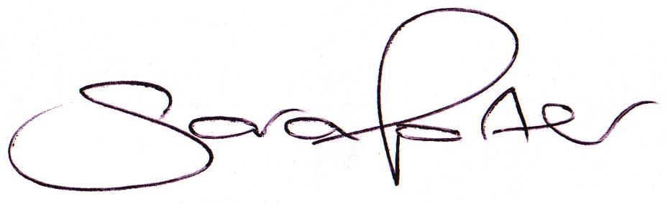

Sara Porter (Mrs)
Parish Clerk
3rd October 2018

The meeting is open to the press and public. Any parishioner wishing to raise a matter on the agenda should speak when invited by the Chairman during the ‘Public Open Forum’.
AGENDA
- To receive and accept apologies and reasons for absence
- To receive declarations of interest for items on the agenda and any requests for dispensation
- To agree the minutes of the meeting held on Monday, 16th July 2018 (Items 1015-1026)
To adjourn the meeting in order to allow reports and the press and/or members of the public to address the Council in a PUBLIC OPEN FORUM
Reports
County Councillor
Borough Councillors
Public Participation (maximum 15 minutes – 3 minutes per speaker)
- To discuss Finance
  - To receive the Clerk’s financial report and bank reconciliation (circulated with agenda)
  - To receive update on the current online banking arrangements
  - To consider purchasing a Royal British Legion Remembrance wreath at a cost of £25.00 (Section 137 (1) of the Local Government Act 1972)
  - To receive and agree the finances since the last meeting and approve payments and pending disbursements to be made:
Date | Payee | Description | Transaction | Net £ | VAT £ | Gross £ | Receipt £
11.08.2018 | E-On | Street Lighting Supply July 2018 | DD | 30.08 | 1.50 | 31.58 | 0.00
03.09.2018 | Barclays Bank Plc | Bank Interest | BACS | 0.00 | 0.00 | 0.00 | 3.29
11.09.2018 | E-On | Street Lighting Supply August 2018 | DD | 30.08 | 1.50 | 31.58 | 0.00
28.09.2018 | AA Membership | Transaction Under Investigation | DD | 155.00 | 0.00 | 155.00 | 0.00
08.10.2018 | Clerk | Salary Jul, Aug, Sep 2018 | 100549 | 516.27 | 0.00 | 516.27 | 0.00
08.10.2018 | Westotec | Street Lighting Maint Aug, Sep 2018 | 100550 | 21.10 | 4.22 | 25.32 | 0.00
08.10.2018 | Royal British Legion | Remembrance Wreath | 100551 | 25.00 | 0.00 | 25.00 | 0.00
08.10.2018 | Joint Burial Board | Burial precept | 100552 | 500.00 | 0.00 | 500.00 | 0.00
Totals this month |  |  |  | 1,277.53 | 7.23 | 1,284.76 | 3.29

- To receive the Notice of Conclusion of Audit for the Annual Governance & Accountability Return
- To approve the following Council policies and procedures (available to view on the website unless otherwise stated)
  - Compliments and/or Complaints
  - Equal Opportunities
  - Freedom of Information Model Publication Scheme
  - Press/Social Media
  - Section 137 (S137) Grants and Donations
  - Unreasonably Persistent And/Or Vexatious Complainants
- To consider planning applications, planning decisions and other planning notifications from the BCKL&WN
  - Planning applications
    - 18/01369/F – Fendale, Downham Road, Salters Lode – Proposed extension, alterations and loft conversion – comments by 21st August 2018

  - Planning decisions
    - 18/01369/F – Fendale, Downham Road, Salters Lode – Proposed extension, alterations and loft conversion – Application permitted (delegated decision)
  - Planning enforcements / appeals and other notifications
  - To receive and consider Late Planning applications
- To receive and discuss correspondence
  - For action/information
    - Norfolk Against Scams Partnership – Invitation for Town and Parish Councils to support the Norfolk Against Scams Partnership (NASP) of organisations working together to take a stand against scams
  - Late correspondence
- Parish Partnership Scheme 2019/2020 – Bids to be submitted by Friday, 7th December 2018
  - To discuss meeting with Highways Engineer, Mr A Wallace, regarding speed signage sites
  - To receive quotations from Westotec for speed signage
  - To consider submitting a bid to Norfolk County Council
- To receive updates and agree action on improvements to the village
  - Speed signs
  - Bus stop
  - Gates
  - Village Tidy Up
  - Property in Downham Road, Salters Lode with mobile home and steel container
- To receive items for the next Agenda
- To record the date of the next Full Council meeting:
Monday, 19th November 2018 at 7.00pm in the Downham Market Town Council Offices, Paradise Road

