Downham West Parish Council

Chairman, Mr Robin Pegg
Willowbrook Cottage, Watermans Way
Salters Lode, Downham Market, Norfolk, PE38 0BD
01366 385815
robin.pegg@openworld .com
Parish Clerk, Mrs Sara Porter
The Old School House, High Street
Stoke Ferry, King’s Lynn, Norfolk, PE33 9SF
01366 502165
dwpc01 @gmail.com

downhamwestparishcouncil.norfolkparishes.gov.uk/

You are hereby summoned to attend the Full Council meeting of Downham West Parish Council on Monday, 19th November 2018 at 7.00pm in the Town Council Offices, Paradise Road, Downham Market, PE38 9HS for the purpose of transacting the business on the agenda below.
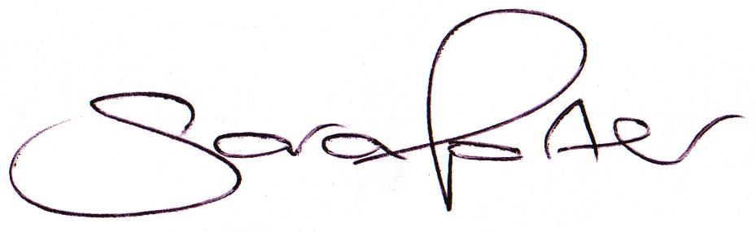

Sara Porter (Mrs)
Parish Clerk
14th November 2018

The meeting is open to the press and public. Any parishioner wishing to raise a matter on the agenda should speak when invited by the Chairman during the ‘Public Open Forum’.
AGENDA
- To receive and accept apologies and reasons for absence
- To receive declarations of interest for items on the agenda and any requests for dispensation
- To agree the minutes of the meeting held on Monday, 8th October 2018 (Items 1027-1038)
To adjourn the meeting in order to allow reports and the press and/or members of the public to address the Council in a PUBLIC OPEN FORUM
Reports
County Councillor
Borough Councillors
Public Participation (maximum 15 minutes – 3 minutes per speaker)
- To discuss Finance
  - To receive the Clerk’s financial report and bank reconciliation (circulated with agenda)
  - To receive update on the current online banking arrangements
  - To receive and agree the finances since the last meeting and approve payments and pending disbursements to be made:
Date | Payee | Description | Transaction | Net £ | VAT £ | Gross £ | Receipt £
12.10.2018 | E-On | Street Lighting Supply September 2018 | DD | 29.11 | 1.46 | 30.57 | 0.00
19.11.2018 | Clerk | Salary Oct 2018 | 100554 | 172.09 | 0.00 | 172.09 | 0.00
19.11.2018 | Westcotec | Street Lighting Maintenance Nov 2018 | 100555 | 10.55 | 2.11 | 12.66 | 0.00
Totals this month |  |  |  | 211.75 | 3.57 | 215.32 | 0.00

- To discuss and approve the draft budget 2019/2020 (circulated with agenda)
- To approve and adopt the updated Standing Orders in accordance with the NALC Model Standing Orders 2018 England (circulated with agenda)
- To approve the policy Powers & Duties & S137 LGA Summary 1972 (circulated with agenda)
- To approve the 2019 meeting dates (circulated with agenda)
- To consider archiving the Council’s historical records at the Norfolk Record Office
- To consider planning applications, planning decisions and other planning notifications from the BCKL&WN
  - Planning applications: none received

  - Planning decisions: none received
  - Planning enforcements / appeals and other notifications
  - To receive and consider Late Planning applications
- To receive and discuss correspondence
  - For action/information
  - Late correspondence
- Parish Partnership Scheme 2019/2020 – Bids to be submitted by Friday, 7th December 2018
  - To receive quotations from Westotec for speed signage
  - To consider and approve the submission of a bid to Norfolk County Council
- To receive updates and agree action on improvements to the village
  - Bus stop
  - Gates
  - Village Tidy Up
- To receive items for the next Agenda
- To record the date of the next Full Council meeting:
Monday, 21st January 2019 at 7.00pm in the Downham Market Town Council Offices, Paradise Road

