Downham West Parish Council

Chairman, Mr Robin Pegg
Willowbrook Cottage, Watermans Way
Salters Lode, Downham Market, Norfolk, PE38 0BD
01366 385815
robin.pegg@openworld .com
Parish Clerk, Mrs Sara Porter
The Old School House, High Street
Stoke Ferry, King’s Lynn, Norfolk, PE33 9SF
01366 502165
dwpc01 @gmail.com

downhamwestparishcouncil.norfolkparishes.gov.uk/

You are hereby summoned to attend the Full Council meeting of Downham West Parish Council on Monday, 21st January 2019 at 7.00pm in the Town Council Offices, Paradise Road, Downham Market, PE38 9HS for the purpose of transacting the business on the agenda below.
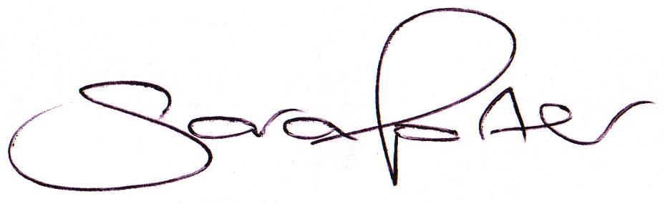

Sara Porter (Mrs)
Parish Clerk
16th January 2019

The meeting is open to the press and public. Any parishioner wishing to raise a matter on the agenda should speak when invited by the Chairman during the ‘Public Open Forum’.
AGENDA
- To receive and accept apologies and reasons for absence
- To receive declarations of interest for items on the agenda and any requests for dispensation
- To agree the minutes of the meeting held on Monday, 19th November 2018 (Items 1039-1054)
To adjourn the meeting in order to allow reports and the press and/or members of the public to address the Council in a PUBLIC OPEN FORUM
Reports
County Councillor
Borough Councillors
Public Participation (maximum 15 minutes – 3 minutes per speaker)
- To discuss Finance
  - To receive the Clerk’s financial report and bank reconciliation (circulated with agenda)
  - To receive update on the current online banking arrangements
  - That the Clerk attends a Norfolk ALC course, Elections 2019, on Tuesday, 29th January 2019 at Wereham Village Hall at a cost of £30.00, split equally with Marham and Watlington Parish Councils
  - To receive and agree the finances since the last meeting and approve payments and pending disbursements to be made:
Date | Payee | Description | Transaction | Net £ | VAT £ | Gross £ | Receipt £
03.12.2018 | Barclays Bank Plc | Bank Interest | BACS | 0.00 | 0.00 | 0.00 | 5.70
11.12.2018 | E-On | Street Lighting Supply November 2018 | DD | 29.11 | 1.46 | 30.57 | 0.00
18.12.2018 | EE Broadband | Transaction Under Investigation | DD | 38.00 | 0.00 | 38.00 | 0.00
04.01.2019 | EE Broadband | Bank Refunded | DD | 0.00 | 0.00 | 0.00 | 38.00
11.01.2019 | E-On | Street Lighting Supply December 2018 | DD | 30.08 | 1.50 | 31.58 | 0.00
21.01.2019 | Westotec | Street Lighting Maint Dec & Jan 2019 | 100556 | 21.10 | 4.22 | 25.32 | 0.00
21.01.2019 | Clerk | Salary Nov & Dec 2018 | 100557 | 344.18 | 0.00 | 344.18 | 0.00
21.01.2019 | HMRC | Employer PAYE/NI Jul-Dec 2018 | 100558 | 76.34 | 0.00 | 76.34 | 0.00
21.01.2019 | Norfolk ALC | Clerk Elections Course | 100559 | 10.00 | 2.00 | 12.00 | 0.00
Totals this month |  |  |  | 548.81 | 9.18 | 557.99 | 43.70

- To receive and consider 2019/2020 draft Budget and approve final Budget (circulated with agenda)
- To receive and consider 2019/2020 proposed Precept and adopt final Precept (circulated with agenda)
- To consider planning applications, planning decisions and other planning notifications from the BCKL&WN
  - Planning applications
    - 18/02075/F – 10 Farthing Road – Proposed 2 storey side and rear extension and single storey replacement outbuilding to form new office/studio – comments by 12th December 2018

  - Planning decisions
    - 18/02075/F – 10 Farthing Road – Proposed 2 storey side and rear extension and single storey replacement outbuilding to form new office/studio – Application permitted (Delegated decision)
  - Planning enforcements / appeals and other notifications
  - To receive and consider Late Planning applications
- To receive and discuss correspondence
  - For action/information
  - Late correspondence
- To receive updates and agree action on improvements to the village
  - Bus stop
  - Gates
  - Village Tidy Up
- To receive items for the next Agenda
- To record the date of the next Full Council meeting:
Monday, 25th February 2019 at 7.00pm in the Downham Market Town Council Offices, Paradise Road

