Downham West Parish Council

Chairman, Mr Robin Pegg
Willowbrook Cottage, Watermans Way
Salters Lode, Downham Market, Norfolk, PE38 0BD
01366 385815
robin.pegg@openworld .com
Parish Clerk, Mrs Sara Porter
The Old School House, High Street
Stoke Ferry, King’s Lynn, Norfolk, PE33 9SF
01366 502165
dwpc01@gmail.com

downhamwestparishcouncil.norfolkparishes.gov.uk/

You are hereby summoned to attend the Full Council meeting of Downham West Parish Council on Monday, 1st April 2019 at 7.00pm in the Town Council Offices, Paradise Road, Downham Market, PE38 9HS for the purpose of transacting the business on the agenda below.
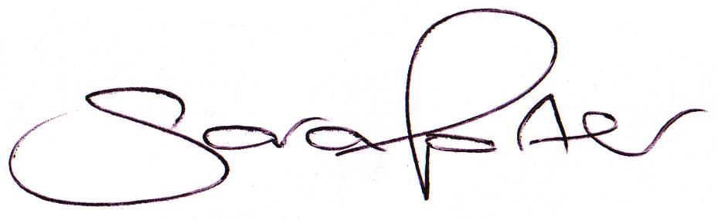

Sara Porter (Mrs)
Parish Clerk
27th March 2019

The meeting is open to the press and public. Any parishioner wishing to raise a matter on the agenda should speak when invited by the Chairman during the ‘Public Open Forum’.
AGENDA
- To receive and accept apologies and reasons for absence
- To receive resignation from Cllr David Beesley and Cllr Paulene Rotman
- To receive declarations of interest for items on the agenda and any requests for dispensation
- To agree the minutes of the meeting held on Monday, 25th February 2019 (Items 1066-1077)
To adjourn the meeting in order to allow reports and the press and/or members of the public to address the Council in a PUBLIC OPEN FORUM
Reports
County Councillor
Borough Councillors
Public Participation (maximum 15 minutes – 3 minutes per speaker)
- To discuss Finance
  - To receive the Clerk’s financial report and bank reconciliation (circulated with agenda)
  - To receive update on the current banking arrangements
  - To receive and agree the finances since the last meeting and approve payments and pending disbursements to be made:
Date | Payee | Description | Transaction | Net £ | VAT £ | Gross £ | Receipt £
04.03.2019 | Barclays Bank Plc | Bank Interest | BACS | 0.00 | 0.00 | 0.00 | 5.66
11.03.2019 | E-On | Street Lighting Supply February 2019 | DD | 33.54 | 1.68 | 35.22 | 0.00
11.03.2019 | Clerk | Salary Feb 2019 | 100562 | 172.09 | 0.00 | 172.09 | 0.00
11.03.2019 | HMRC | Employer PAYE/NI Jan-Feb 2019 | 100563 | 86.20 | 0.00 | 86.20 | 0.00
25.03.2019 | Westotec | Street Light Feb 19 Duplicate Payment | DD | 10.55 | 2.11 | 12.66 | 0.00
27.03.2019 | Westotec | Street Light Feb 19 Duplicate Refunded | DD | -10.55 | -2.11 | -12.66 | 0.00
01.04.2019 | Clerk | Salary Mar 2019 | 100564 | 172.09 | 0.00 | 172.09 | 0.00
01.04.2019 | HMRC | Employer PAYE/NI Jan-Feb 2019 | 100565 | 43.00 | 0.00 | 43.00 | 0.00
01.04.2019 | Clerk | Postage stamps 24 x 2nd class | 100566 | 13.92 | 0.00 | 13.92 | 0.00
Totals this month |  |  |  | 520.84 | 1.68 | 522.52 | 5.66

- Elections 2nd May 2019 – timetable update

- Parish Partnership Scheme 2019/2020 – Bid part approval from Norfolk County Council
  - To consider preferred location for one Vehicle Activated Sign (VAS)
- To consider planning applications, planning decisions and other planning notifications from the BCKL&WN
  - Planning applications
    - 19/00426/RM – Land On The North East of 4 And 5 Watermans Way, Salters Lode – Reserved Matters: Erection of one dwelling (Plot 2) – comments by 2nd April 2019

  - Planning decisions – none received
  - Planning enforcements / appeals and other notifications
  - To receive and consider Late Planning applications
- To receive and discuss correspondence
  - For action/information
    - Local Plan Review [Core Strategy (CS) adopted in 2011 and Site Allocations and Development Management Policies Plan (SADMP) adopted in 2016 combined draft document setting out a strategy and detail for delivering growth in the Borough, identifying where development should be located and how it should be delivered up to 2036] – Consultation Draft (4th March 2019 – 15th April 2019) (circulated prior to agenda)
  - Late correspondence
- To receive updates on ongoing matters
  - Council archives
- To receive updates and agree action on improvements to the village
  - Bus stop
  - Gates
- To receive items for the next Agenda
- To record the date of the next Full Council meeting:
Monday, 13th May 2019 (Annual Meeting) at 7.00pm in the Downham Market Town Council Offices, Paradise Road – elected Members should make every effort to attend this meeting
- Exclusion of Press and Public – To consider a resolution under the Public Bodies (Admission to meetings) Act 1960 Section 1 that the press and public be excluded from the meeting in order to discuss the following confidential item
  - To review the Clerk’s salary in accordance with the contract (NALC pay scales circulated with agenda)

