Downham West Parish Council

Chairman, Mr Robin Pegg
Willowbrook Cottage, Watermans Way
Salters Lode, Downham Market, Norfolk, PE38 0BD
01366 385815
robin.pegg@openworld .com
Parish Clerk, Mrs Sara Porter
The Old School House, High Street
Stoke Ferry, King’s Lynn, Norfolk, PE33 9SF
01366 502165
dwpc01 @gmail.com

downhamwestparishcouncil.norfolkparishes.gov.uk

You are hereby summoned to attend the Annual Meeting of Downham West Parish Council on Monday, 13th May 2019 at 7.00pm in the Town Council Offices, Paradise Road, Downham Market, PE38 9HS for the purpose of transacting the business on the agenda below.

All newly Elected Members are expected to attend this meeting and should arrive no later than 6.45pm to read, complete and sign their Declaration of Acceptance of Office, Register of Members Disclosable Interests, Dispensation Request Declaration, Code of Conduct and GDPR Consent Form prior to the meeting.
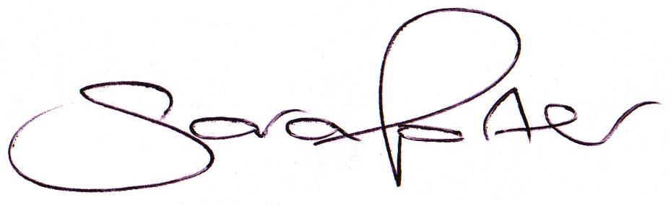

Sara Porter (Mrs)
Parish Clerk
8th May 2019

The meeting is open to the press and public. Any parishioner wishing to raise a matter on the agenda should speak when invited by the Chairman during the ‘Public Open Forum’.
AGENDA
- Election of Chairman of the Council and Declaration of Acceptance of Office
- Election of Vice Chairman of the Council and Declaration of Acceptance of Office
- To receive and accept apologies and reasons for absence
- To receive declarations of interest for items on the agenda and any requests for dispensation
- To agree the minutes of the Council meeting held on Monday, 1st April 2019 (Items 1078-1091)
- To review Councillors’ areas of responsibilities, outside body representation and working parties
  - Downham Market & Downham West Joint Burial Board (Currently Cllr Pegg)
  - Hundred Acre Common Charity (Currently Cllr Pegg)
- To review the Council policies and procedures (available to view on the website unless otherwise stated)
  - Standing Orders
  - Financial Regulations
  - Powers & Duties
  - Compliments & Complaints
  - Equal Opportunities
  - Freedom of Information Model Publication Scheme
  - Parish Council Risk Assessment
  - Press/Social Media
  - S137 Grants & Donations
  - Unreasonably Persistent And/Or Vexatious Complainants
To adjourn the meeting in order to allow reports and the press and/or members of the public to address the Council in a PUBLIC OPEN FORUM
Reports
County Councillor
Borough Councillors
Public Participation (maximum 15 minutes – 3 minutes per speaker)
- Elections 2nd May 2019 – Declarations of Result and Candidate Election Expenses
- To discuss Finance
  - To receive the Clerk’s financial report and bank reconciliation (circulated with agenda)
  - To receive update on the current banking arrangements
  - To receive and agree the finances since the last meeting and approve payments and pending disbursements to be made:
Date | Payee | Description | Transaction | Net £ | VAT £ | Gross £ | Receipt £
02.04.2019 | Westotec | Street Lighting Mar 2019 | DD | 10.55 | 2.11 | 12.66 | 0.00
12.04.2018 | E-On | Street Lighting Supply March 2019 | DD | 37.14 | 1.86 | 39.00 | 0.00
15.04.2019 | BCKL&WN | Precept & Council Support Grant | BACS | 0.00 | 0.00 | 0.00 | 5,819.00
25.04.2019 | HMRC | VAT Return 2018/2019 | BACS | 0.00 | 0.00 | 0.00 | 150.41
07.05.2019 | Westotec | Street Lighting Mar 2019 | DD | 10.55 | 2.11 | 12.66 | 0.00
11.05.2019 | E-On | Street Lighting Supply April 2019 | DD | 35.94 | 1.80 | 37.74 | 0.00
13.05.2019 | Norfolk County Council | Parish Partnership 2019 2020 |  | 3,150.00 | 0.00 | 3,150.00 | 0.00
13.05.2019 | Norfolk ALC | Annual Membership 2019 2020 |  | 105.55 | 0.00 | 105.55 | 0.00
13.05.2019 | Clerk | Printer cartridges (Transparency Fund) |  | 35.53 | 7.11 | 42.64 | 0.00
13.05.2019 | Clerk | Salary Apr 2019 |  | 178.91 | 0.00 | 178.91 | 0.00
13.05.2019 | HMRC | Employer PAYE/NI Apr 2019 |  | 44.60 | 0.00 | 44.60 | 0.00
13.05.2019 | Mr J Cross | Internal Audit |  | 25.00 | 0.00 | 25.00 | 0.00
13.05.2019 | Came & Company | Annual Insurance |  | 604.69 | 0.00 | 604.69 | 0.00
Totals this month |  |  |  | 4,238.46 | 14.98 | 4,253.44 | 5,969.41

- Annual Governance for the Accounts 2018/2019
  - To approve the Certificate of Exemption 2018/2019
  - To approve the Annual Internal Audit Report 2018/2019 and consider any recommendations made
  - To approve the Annual Governance Statement 2018/2019 (Section 1 Annual Return)
  - To approve the Accounting Statements 2018/2019 (Section 2 Annual Return)
  - To approve the Notice of Appointment of Date for the Exercise of Electors’ Rights
- Parish Partnership Scheme 2019/2020 (Vehicle Activated Sign - War Memorial, Salters Lode, A1122
- To consider planning applications, planning decisions and other planning notifications from the BCKL&WN
  - Planning applications – none received

  - Planning decisions – none received
  - Planning enforcements / appeals and other notifications
  - To receive and consider Late Planning applications
- To receive and discuss correspondence
  - For action/information
  - Late correspondence
- To receive updates on ongoing matters
  - Council archives
- To receive updates and agree action on improvements to the village
  - Bus stop
  - Gates
- To receive items for the next Agenda
- To record the date of the next Full Council meeting:
Monday, 10th June 2019 at 7.00pm in the Downham Market Town Council Offices, Paradise Road

