Downham West Parish Council

Chairman, Mr Robin Pegg
Willowbrook Cottage, Watermans Way
Salters Lode, Downham Market, Norfolk, PE38 0BD
01366 385815
robin.pegg@openworld .com
Parish Clerk, Mrs Sara Porter
The Old School House, High Street
Stoke Ferry, King’s Lynn, Norfolk, PE33 9SF
01366 502165
dwpc01 @gmail.com

downhamwestparishcouncil.norfolkparishes.gov.uk

You are hereby summoned to attend the Full Council meeting of Downham West Parish Council on Monday, 22nd July 2019 at 7.00pm in the Town Council Offices, Paradise Road, Downham Market, PE38 9HS for the purpose of transacting the business on the agenda below.
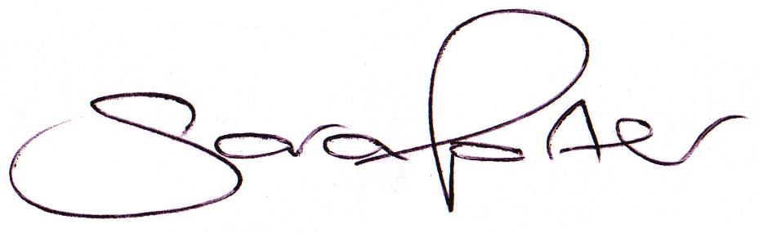

Sara Porter (Mrs)
Parish Clerk
17th July 2019

The meeting is open to the press and public. Any parishioner wishing to raise a matter on the agenda should speak when invited by the Chairman during the ‘Public Open Forum’.

AGENDA
- To receive and accept apologies and reasons for absence
- To receive declarations of interest for items on the agenda and any requests for dispensation
- To agree the minutes of the Council Meeting held on Monday, 10th June 2019 (Items 1109-1119)
- To receive application for the Casual Vacancy and consider and resolve the Co-option for the position of Councillor
  - If elected, to resolve that the Councillor is granted a dispensation until the end of their term in May 2023, or resignation, whichever is the sooner, to enable them to take part in Council business where this would otherwise be prohibited because they have a Disclosable Pecuniary Interest.
- To receive update on the casual vacancies – Clerk to report
- Update on previous minutes (not listed elsewhere on the agenda and for information only)
- To receive any Councillors’ issues
To adjourn the meeting in order to allow reports and the press and/or members of the public to address the Council in a PUBLIC OPEN FORUM
Reports
County Councillor
Borough Councillors
Public Participation (maximum 15 minutes – 3 minutes per speaker)
- To discuss Finance
  - To receive the Clerk’s financial report and bank reconciliation (circulated with agenda)
  - To receive update on the current banking arrangements
  - To receive and agree the finances since the last meeting and approve payments and pending disbursements to be made:
Date | Payee | Description | Transaction | Net £ | VAT £ | Gross £ | Receipt £
11.06.2019 | E-On | Street Lighting Supply May 2019 | DD | 37.14 | 1.86 | 39.00 | 0.00
18.06.2019 | Westotec | Street Lighting May 2019 | DD | 10.55 | 2.11 | 12.66 | 0.00
24.06.2019 | Information Commissioner | Data Protection Registration | DD | 35.00 | 0.00 | 35.00 | 0.00
02.07.2019 | Westotec | Street Lighting June 2019 | DD | 10.55 | 2.11 | 12.66 | 0.00
12.07.2019 | E-On | Street Lighting Supply June 2019 | DD | 35.94 | 1.80 | 37.74 | 0.00
22.07.2019 | Clerk | Salary June 2019 | 100576 | 178.71 | 0.00 | 178.71 | 0.00
22.07.2019 | BCKL&WN | Election Recharge Costs | 100577 | 48.26 | 0.00 | 48.26 | 0.00
Totals this month |  |  |  | 262.91 | 1.80 | 264.71 | 0.00

  - To agree Cllr Candler attending a Norfolk ALC training course, Being an Effective Councillor, at Wereham Village Hall on Monday, 9th September 2019 at a cost of £60.00 + 12.00 VAT and approve the course and travel disbursement
  - To agree the attendance of a maximum of two Councillors at the BCKL&WN Planning Update Session on Wednesday, 25th September 2019 and approve the travel disbursement
- Parish Partnership Scheme 2019/2020 (Vehicle Activated Sign - War Memorial, Salters Lode, A1122)
  - Parish Partnership Scheme 2020/2021 – to consider scheme(s) for submission (bids to be submitted by Friday, 6th December 2019)
- To consider planning applications, planning decisions and other planning notifications from the BCKL&WN
  - Planning applications
    - 19/00935/F – Land On The North East of 4 And 5 Watermans Way, Salters Lode – Construction of one pair of semi-detached houses – comments by 4th July 2019
    - 19/01120/F – Orchard Farm House, Lady Drove, Barroway Drove – Extension to rear of detached garage to form a games room – comments by 22nd July 2019

  - Planning decisions – none received
  - Planning enforcements / appeals and other notifications
  - To receive and consider Late Planning applications and decisions
- To receive and discuss correspondence
  - For action/information
    - Mr P Akers – War Memorial grounds maintenance ceasing all duties
  - Late correspondence
- To receive updates on ongoing matters
  - Council archives
- To receive updates and agree action on improvements to the village
  - Involving the Parish community in a unifying project by providing a meeting venue, encouraging an open garden scheme or Neighbourhood Watch – Cllr Candler to report
  - Village Gates
  - Notice boards
- To receive items for the next Agenda
- To record the date of the next Full Council meeting:
Monday, 9th September 2019 at 7.00pm in the Downham Market Town Council Offices, Paradise Road

