Downham West Parish Council

Chairman, Mr Robin Pegg
Willowbrook Cottage, Watermans Way
Salters Lode, Downham Market, Norfolk, PE38 0BD
01366 385815
robin.pegg@openworld .com
Parish Clerk, Mrs Sara Porter
The Old School House, High Street
Stoke Ferry, King’s Lynn, Norfolk, PE33 9SF
01366 502165
dwpc01 @gmail.com

downhamwestparishcouncil.norfolkparishes.gov.uk

You are hereby summoned to attend the Full Council meeting of Downham West Parish Council on Monday, 14th October 2019 at 7.00pm in the Assembly Room, Downham Market Town Hall for the purpose of transacting the business on the agenda below.
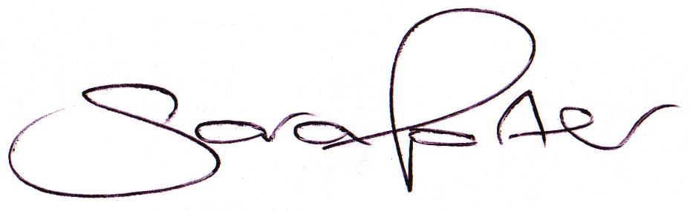

Sara Porter (Mrs)
Parish Clerk
9th October 2019

The meeting is open to the press and public. Any parishioner wishing to raise a matter on the agenda should speak when invited by the Chairman during the ‘Public Open Forum’.

AGENDA
- To receive and accept apologies and reasons for absence
- To receive declarations of interest for items on the agenda and any requests for dispensation
- To agree the minutes of the Council Meeting held on Monday, 9th September 2019 (Items 1135-1147)
- Update on previous minutes (not listed elsewhere on the agenda and for information only)
- To receive any Councillors’ issues
To adjourn the meeting in order to allow reports and the press and/or members of the public to address the Council in a PUBLIC OPEN FORUM
Reports
County Councillor
Borough Councillors
Public Participation (maximum 15 minutes – 3 minutes per speaker)
- To discuss Finance
  - To receive the Clerk’s financial report and bank reconciliation (circulated with agenda)
  - To receive update on the current banking arrangements
    - To receive information on the Unity Trust Bank (circulated with agenda)
  - To consider purchasing a Royal British Legion Remembrance wreath at a cost of £25.00 (Section 137 (1) of the Local Government Act 1972)
  - To receive and agree the finances since the last meeting and approve payments and pending disbursements to be made:
Date | Payee | Description | Transaction | Net £ | VAT £ | Gross £ | Receipt £
11.09.2019 | E-On | Street Lighting Supply August 2019 | DD | 37.14 | 1.86 | 39.00 | 0.00
07.10.2019 | Westotec | Street Lighting September 2019 | DD | 10.55 | 2.11 | 12.66 | 0.00
11.10.2019 | E-On | Street Lighting Supply Sep 2019 | DD | 35.94 | 1.80 | 37.74 | 0.00
14.10.2019 | Clerk | Salary September 2019 |  | 178.71 | 0.00 | 178.71 | 0.00
14.10.2019 | Norfolk ALC | Cllr Training |  | 60.00 | 12.00 | 72.00 | 0.00
Totals this month |  |  |  | 322.34 | 17.76 | 340.10 | 0.00

- Parish Partnership Scheme
  - Parish Partnership Scheme 2019/2020 (Vehicle Activated Sign - War Memorial, Salters Lode, A1122)
  - Parish Partnership Scheme 2020/2021 – to consider scheme(s) for submission (bids to be submitted by Friday, 6th December 2019)
- To consider planning applications, planning decisions and other planning notifications from the BCKL&WN
  - Planning applications

  - Planning decisions
    - 19/00829/PACU3 – Orchard Farm, Lady Drove, Barroway Drove – Notification for Prior Approval for change of use of agricultural building to a dwellinghouse (Schedule 2, Part 3, Class Q) – Prior Approval Refused (Delegated Decision)
  - Planning enforcements / appeals and other notifications
  - To receive and consider Late Planning applications and decisions
- To receive and discuss correspondence
  - For action/information
    - Local Government Boundary Commission Public Consultation on division boundaries for Norfolk County Council (closing date 2nd December 2019)
  - Late correspondence
- To receive updates on ongoing matters
  - Council archives
- To receive updates and agree action on improvements to the village
  - Involving the Parish community in a unifying project by providing a meeting venue, encouraging an open garden scheme or Neighbourhood Watch – Cllr Candler to report
  - Village Gates
  - Bus stop sign
- To receive items for the next Agenda
- To record the date of the next Full Council meeting:
Monday, 18th November 2019 at 7.00pm in the Assembly Room, Downham Market Town Hall

