Downham West Parish Council

Chairman, Mr Robin Pegg
Willowbrook Cottage, Watermans Way
Salters Lode, Downham Market, Norfolk, PE38 0BD
01366 385815
robin.pegg@btopenworld.com
Parish Clerk, Mrs Sara Porter
The Old School House, High Street
Stoke Ferry, King’s Lynn, Norfolk, PE33 9SF
01366 502165
dwpc01@gmail.com

downhamwestparishcouncil.norfolkparishes.gov.uk

You are hereby summoned to attend the Full Council meeting of Downham West Parish Council on Monday, 18th November 2019 at 7.00pm in the Assembly Room, Downham Market Town Hall for the purpose of transacting the business on the agenda below.
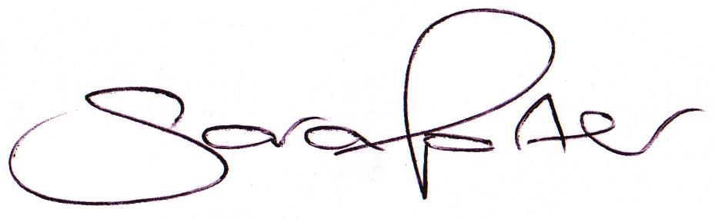

Sara Porter (Mrs)
Parish Clerk
13th November 2019

The meeting is open to the press and public. Any parishioner wishing to raise a matter on the agenda should speak when invited by the Chairman during the ‘Public Open Forum’.

AGENDA
- To receive and accept apologies and reasons for absence
- To receive declarations of interest for items on the agenda and any requests for dispensation
- To agree the minutes of the Council Meeting held on Monday, 14th October 2019 (Items 1148-1160)
- Update on previous minutes (not listed elsewhere on the agenda and for information only)
- To receive any Councillors’ issues
To adjourn the meeting in order to allow reports and the press and/or members of the public to address the Council in a PUBLIC OPEN FORUM
Reports
County Councillor
Borough Councillors
Public Participation (maximum 15 minutes – 3 minutes per speaker)
- To discuss Finance
  - To receive the Clerk’s financial report and bank reconciliation (circulated with agenda)
  - To receive and agree the finances since the last meeting and approve payments and pending disbursements to be made:
Date | Payee | Description | Transaction | Net £ | VAT £ | Gross £ | Receipt £
18.11.2019 | E-On | Street Lighting October 2019 | DD | 37.14 | 1.86 | 39.00 | 0.00
 | Clerk | Salary October 2019 | BACS | 178.91 | 0.00 | 178.91 | 0.00
 | HMRC | Employer PAYE/NI Sep-Oct 2019 | BACS | 89.40 | 0.00 | 89.40 | 0.00
 | DM&DW Joint Burial Board | Burial precept | BACS | 550.00 | 0.00 | 550.00 | 0.00
 | Clerk | Remembrance Wreath (RBL) | BACS | 25.00 | 0.00 | 25.00 | 0.00
 | Westotec | Street Lighting October 2019 | DD | 10.55 | 2.11 | 12.66 | 0.00
Totals this month |  |  |  | 891.00 | 3.97 | 894.97 | 0.00

- To discuss and approve the draft budget 2020/2021 (circulated with agenda)
- To approve the 2020 Council meeting dates (circulated with agenda)
- Parish Partnership Scheme
  - Parish Partnership Scheme 2019/2020 (Vehicle Activated Sign - War Memorial, Salters Lode, A1122)
  - Parish Partnership Scheme 2020/2021 – to consider scheme(s) for submission (bids to be submitted by Friday, 6th December 2019)
- To consider planning applications, planning decisions and other planning notifications from the BCKL&WN
  - Planning applications

  - Planning decisions
  - Planning enforcements / appeals and other notifications
  - To receive and consider Late Planning applications and decisions
- To receive and discuss correspondence
  - For action/information
  - Late correspondence
- To receive updates on ongoing matters
  - Council archives
- To receive updates and agree action on improvements to the village
  - Involving the Parish community in a unifying project by providing a meeting venue, encouraging an open garden scheme or Neighbourhood Watch – Cllr Candler to report
  - Village Gates
  - Bus stop sign
- To receive items for the next Agenda
- To record the date of the next Full Council meeting:
Monday, 13th January 2020 at 7.00pm in the Assembly Room, Downham Market Town Hall

